Peria Nallathambi
[Email address]
Abstract
This document explain about google My Business Profile and how it can be integrated with Clinic information in Dynamics CRM and how to expose the Clinic Information like address, working hours ,location to the third party application.
Clinic profile sync
SPIKE 142565

Table of Contents
Introduction 2
Google Business Profile 2
MIS to Google My Business Integration 2
MIS to third party Integration (Landing page, TXWIC website) 4
Google My Business Profile API 5
Prerequisites 6
OAuth Client ID 6
Challenges 6

Introduction
This document provides information about the details of storing clinic information at a central location and how to synchronize clinic location , working hours and contact details of Clinic with other platforms like Google Business , Portal Landing Pages, Texaswic.org etc. .
Feature 138700: Single source of truth for BU/Clinic profile

Google Business Profile
Google Business Profile is used to control how to business (Clinic) gets displayed in Google Search. For example , the below screenshot shows how ‘South Austin WIC Clinic’ is shown in google search . The Google search page lists Clinic Address , contact number , working hours , website, and other details (which may not be required for our spike story).
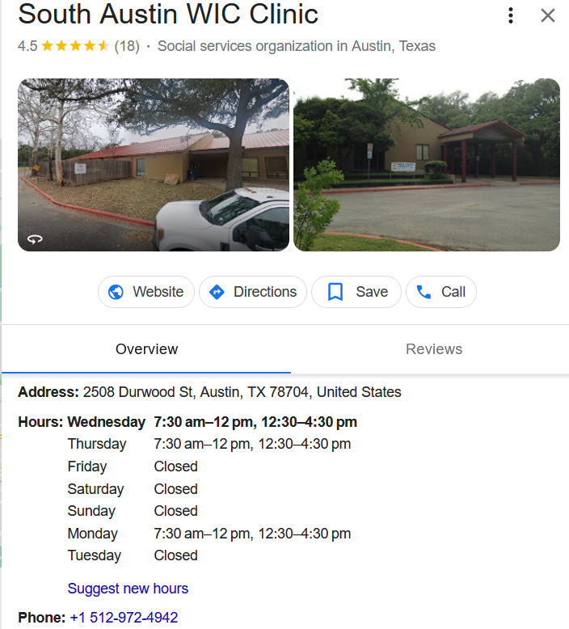

When you are signed in as a chain Business Profile, Clinic information can be updated in bulk using an excel sheet template. This is the approach currently followed by the WIC to update Google Business Profile(https://support.google.com/business/answer/9336353?hl=en ).

MIS to Google My Business Integration
Clinic Profile Information is stored in MOSAIC app both at ‘Clinic/Local Agency’ and ‘CalendarRule’ records .
Clinic/Local Agency
- Clinic Name
- Clinic Address
- Clinic Contact Number
- Website
- Location
Calendar
- Work Hours
- Holidays
Changes made in Clinic/Local Agency will be pushed to Azure Service Bus and Azure Function App processes the change and updates in Google Business.
But in case the workhours/holidays can’t be synchronized by above mentioned approach since we can’ register plugins against ‘CalendarRule’ entity, we can only query the schedule of specific clinic using an API. Every day, we can query for the Schedule of the clinic and if there is any change in schedule, it can be compared to the existing schedule in google Business, then the change can be updated in Google Business using a Batch Job.
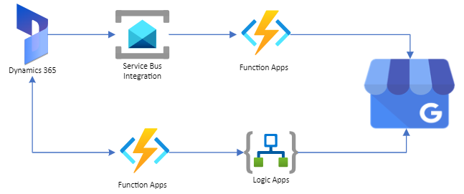

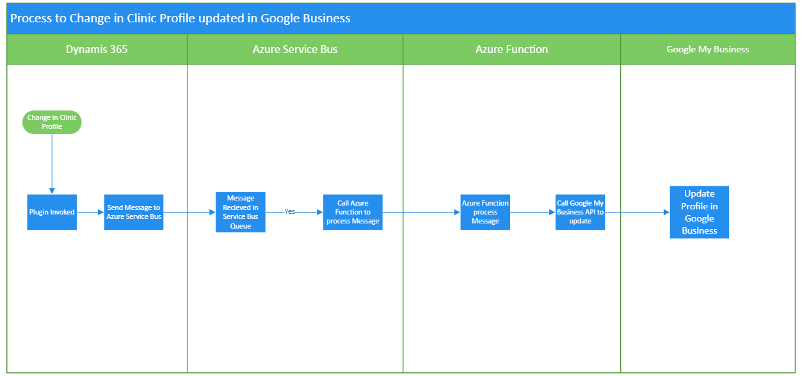

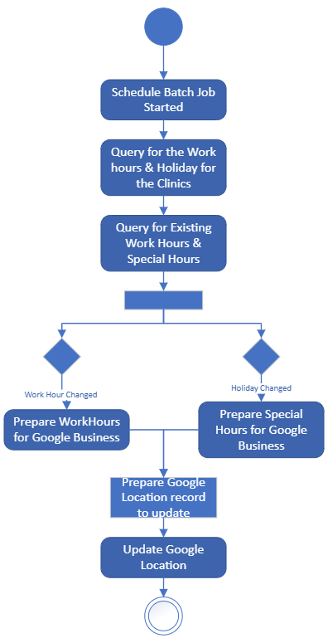

MIS to third party Integration (Landing page, TXWIC website)
The Clinic Profile information can be exposed to third party systems through web API. They can query the clinic profile information by passing the unique id to identify the clinic and response to the query will be return in JSON format.
https://clinicprofile.azurewebsites.us/api/Release?clinicId=367
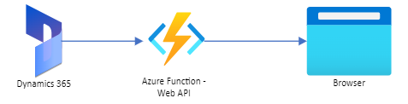

The JSON output can be like below:
{
"ClinicName":"Rosewood Zaragosa Neighborhood Center",
“ClinicId”: “367”,
"Address": "2800 Webberville Rd, Austin, TX 78702",
"PrimaryPhoneNumber": "512 972 6740",
"AdditionalPhoneNumber": " ",
"Website": "http://www.austintexas.gov/department/rosewood-zaragosa-neighborhood-center",
"Location": "30.275837, -97.741196",
"Workinghours":[
{
"WorkDay":"Monday",
"IsClosed": false,
"OpenTime": "07:00 AM",
"CloseTime": "12:00 PM"
},
{
"WorkDay":"Monday",
"IsClosed": false,
"OpenTime": "12:30 PM",
"CloseTime": "05:00 PM"
},
{
"WorkDay":"TuesDay",
"IsClosed": true,
"OpenTime": "",
"CloseTime": ""
},
{
"WorkDay":"Wednesday",
"IsClosed": false,
"OpenTime": "07:00 AM",
"CloseTime": "12:00 PM"
},
{
"WorkDay":"Wednesday",
"IsClosed": false,
"OpenTime": "12:30 PM",
"CloseTime": "05:00 PM"
}
]
}

Google My Business Profile API
The Business Profile APIs provides an interface to manage business location information on Google. The APIs use a federated model that includes separate endpoints for different functionality (https://developers.google.com/my-business/ref_overview) .
- Account Management API
- Business Calls API
- Lodging API
- Place Actions API
- Notifications API
- Verifications API
- Business Information API
- Q&A API
- Business Profile Performance API
For our purpose, we need only “Account Management API” and “Business Information API”.

Prerequisites needed for successful integration.
- Need a valid Google Account
- Business Profile should be created and google account should be linked to the business Profile
- Create Project in Google API Console (https://console.developers.google.com/project)
- Request Access to API (https://docs.google.com/forms/d/1XTQc-QEjsE7YrgstyJxbFDnwmhUhBFFvpNJBw3VzuuE/viewform )
- Enable API: The following API should be enabled for the profile from library
  - My Business Account Management API
  - My Business Information API
Note:

OAuth Client ID
Application must sent OAuth 2.0 Token with any Business Profile API request to access data . oAuth 2.0 credential will be created from Google API Console (https://console.developers.google.com/apis/credentials ) . Since we will use Azure Function to do the integration, check the below URL on how to configure Google Login with Azure Function
https://www.dotnetmirror.com/articles/microsoft-azure/240/configure-google-login-on-your-azure-function-app-with-app-service-authentication

Challenges
- Reading/updating of Google Location attributes are limited by ReadMask/UpdateMask , So we can update the any attributes of Location of change in value of Clinic . UpdateMask to be generated dynamically based on attribute changed in Clinic.
- In Google Location, Working Hours and Holidays/Adhoc changes are defined separately. But In CRM , we can schedule for a specific period like one week which will have regular workhour, Holiday and Ad-hoc work hours . So converting to the format of Google location will be challenging .

